Dannevirke A & P presents
Dress up Your Lamb
11am 6th February 2021
Location: Sheep yards
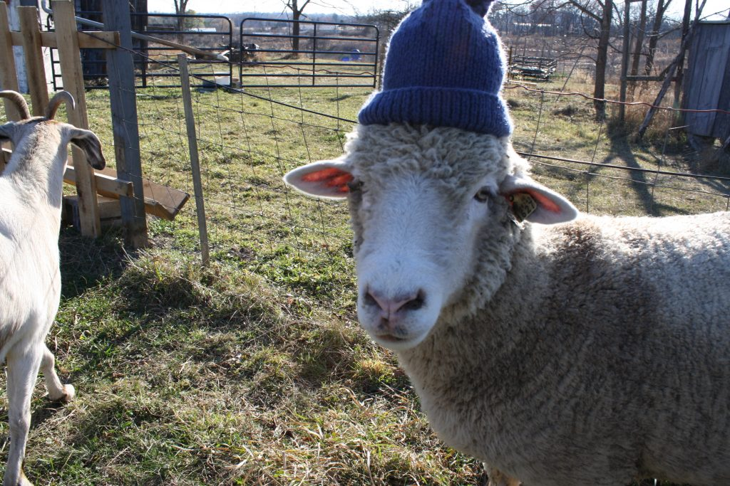
Get creative with your lamb

